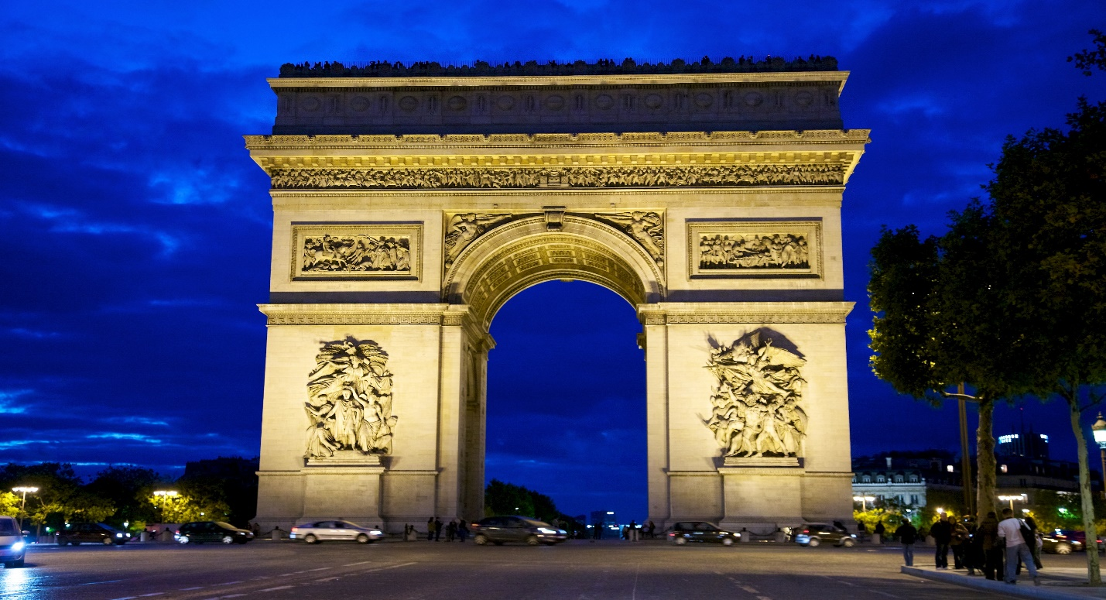

# Arc de Triomphe

The **Arc de Triomphe de l'Étoile**,[[a]](https://en.wikipedia.org/wiki/Arc_de_Triomphe#cite_note-6) often called simply the **Arc de Triomphe**, is one of the most famous monuments in [Paris](https://en.wikipedia.org/wiki/Paris), France, standing at the western end of the [Champs-Élysées](https://en.wikipedia.org/wiki/Champs-%C3%89lys%C3%A9es) at the centre of [Place Charles de Gaulle](https://en.wikipedia.org/wiki/Place_Charles_de_Gaulle), formerly named Place de l'Étoile—the *étoile* or "star" of the juncture formed by its twelve radiating avenues. The location of the arc and the plaza is shared between three [arrondissements](https://en.wikipedia.org/wiki/Arrondissements_of_Paris), [16th](https://en.wikipedia.org/wiki/16th_arrondissement_of_Paris) (south and west), [17th](https://en.wikipedia.org/wiki/17th_arrondissement_of_Paris) (north), and [8th](https://en.wikipedia.org/wiki/8th_arrondissement_of_Paris) (east). The Arc de Triomphe honours those who fought and died for France in the [French Revolutionary](https://en.wikipedia.org/wiki/French_Revolutionary_Wars) and [Napoleonic Wars](https://en.wikipedia.org/wiki/Napoleonic_Wars), with the names of all French victories and generals inscribed on its inner and outer surfaces. Beneath its vault lies the [Tomb of the Unknown Soldier](https://en.wikipedia.org/wiki/Tomb_of_the_Unknown_Soldier_(France)) from [World War I](https://en.wikipedia.org/wiki/World_War_I).

The central cohesive element of the [*Axe historique*](https://en.wikipedia.org/wiki/Axe_historique) (historic axis, a sequence of monuments and grand thoroughfares on a route running from the courtyard of the [Louvre](https://en.wikipedia.org/wiki/Louvre) to the [Grande Arche](https://en.wikipedia.org/wiki/Grande_Arche) de la Défense), the Arc de Triomphe was designed by [Jean Chalgrin](https://en.wikipedia.org/wiki/Jean_Chalgrin) in 1806; its [iconographic](https://en.wikipedia.org/wiki/Iconography) programme pits [heroically nude](https://en.wikipedia.org/wiki/Heroic_nudity) French youths against bearded [Germanic](https://en.wikipedia.org/wiki/Germanic_peoples) warriors in [chain mail](https://en.wikipedia.org/wiki/Chain_mail). It set the tone for public monuments with triumphant patriotic messages. Inspired by the [Arch of Titus](https://en.wikipedia.org/wiki/Arch_of_Titus) in [Rome](https://en.wikipedia.org/wiki/Rome), Italy, the Arc de Triomphe has an overall height of 50 m (164 ft), width of 45 m (148 ft) and depth of 22 m (72 ft), while its large vault is 29.19 m (95.8 ft) high and 14.62 m (48.0 ft) wide. The smaller transverse vaults are 18.68 m (61.3 ft) high and 8.44 m (27.7 ft) wide.

Paris's Arc de Triomphe was the tallest [triumphal arch](https://en.wikipedia.org/wiki/Triumphal_arch) until the completion of the [Monumento a la Revolución](https://en.wikipedia.org/wiki/Monumento_a_la_Revoluci%C3%B3n" \o "Monumento a la Revolución) in [Mexico City](https://en.wikipedia.org/wiki/Mexico_City) in 1938, which is 67 m (220 ft) high. The [Arch of Triumph in Pyongyang](https://en.wikipedia.org/wiki/Arch_of_Triumph_(Pyongyang)), completed in 1982, is modeled on the Arc de Triomphe and is slightly taller at 60 m (197 ft). The [Grande Arche](https://en.wikipedia.org/wiki/Grande_Arche) in [La Défense](https://en.wikipedia.org/wiki/La_D%C3%A9fense) near Paris is 110 metres high, and, if considered to be a triumphal arch, is the world's tallest.[[6]](https://en.wikipedia.org/wiki/Arc_de_Triomphe#cite_note-ParisDigest-7)

## **History**

The Arc de Triomphe is located on the right bank of the [Seine](https://en.wikipedia.org/wiki/Seine) at the centre of a [dodecagonal configuration of twelve radiating avenues](https://en.wikipedia.org/wiki/Place_Charles_de_Gaulle). It was commissioned in 1806, after the victory at [Austerlitz](https://en.wikipedia.org/wiki/Battle_of_Austerlitz) by Emperor [Napoleon](https://en.wikipedia.org/wiki/Napoleon) at the peak of his fortunes. Laying the foundations alone took two years and, in 1810, when Napoleon entered Paris from the west with his new bride, Archduchess [Marie-Louise](https://en.wikipedia.org/wiki/Marie_Louise,_Duchess_of_Parma) of Austria, he had a wooden mock-up of the completed arch constructed. The architect, [Jean Chalgrin](https://en.wikipedia.org/wiki/Jean_Chalgrin), died in 1811 and the work was taken over by [Jean-Nicolas Huyot](https://en.wikipedia.org/wiki/Jean-Nicolas_Huyot).

During the [Bourbon Restoration](https://en.wikipedia.org/wiki/Bourbon_Restoration_in_France), construction was halted, and it would not be completed until the reign of [Louis Philippe I](https://en.wikipedia.org/wiki/Louis_Philippe_I), between 1833 and 1836, by the architects Goust, then Huyot, under the direction of [Héricart de Thury](https://en.wikipedia.org/wiki/Louis-%C3%89tienne_H%C3%A9ricart_de_Thury" \o "Louis-Étienne Héricart de Thury). The final cost was reported at about 10,000,000 francs (equivalent to an estimated €65 million or $75 million in 2020).